Advanced Data Structure Project

Finding frequent items bought by customers using FP trees

Guide : Prof.Srinivasa Murthy

Submitted by :
Team #5
Sujitha Jose 1PI13CS168
C section 4th sem
Sushmita Subramani 1PI13CS173
C section 4th sem

Introduction:

This project gives us an excellent opportunity to explore the structures and implementation of n-ary trees , linked lists , doubly linked lists .
This project was also our self study topic so it felt like a good idea to take on the same as project.

For the implementation of the data structures we had choice between linked list asnd arrays , but we chose the latter because linked lists are dynamic in nature and has multiple types data associated with it .

The fp data mining was the most difficult was the most challenging and interesting part of the project as it involved making the code very efficient for various types of implementation of the fp tree (fp tree being constructed twice for the same problem statement in two different ways ) . Since the code was very lengthy and had lot of data in it debugging was a big task (even bigger than coming up with logic :) ).

Our problem staement was “ Finding frequent items bought by customers using FP trees “ .
Basically finding items that are bought together frequently by customers using FP trees and to make better marketing strategy and grouping them.

The following tasks are performed in the program :
Input list of items bought by each customer . Input also the minimum support threshold.
Calculate the frequency for each item and create a header table for it .
Construct an fp tree and mine frequent item groups from the tree .

Background

Definition : The FP-Growth Algorithm is an efficient and scalable method for mining the complete set of frequent patterns by pattern fragment growth, using an extended prefix-tree structure for storing compressed and crucial information about frequent patterns named frequent-pattern tree (FP-tree) .

Applications : stores quantitative information about frequent patterns in a database
FP-Tree structure
The frequent-pattern tree (FP-tree) is a compact structure that stores quantitative information about frequent patterns in a database .
Han defines the FP-tree as the tree structure defined below ^{[1]}:
One root labeled as “null” with a set of item-prefix subtrees as children, and a frequent-item-header table (presented in the left side of Figure 1);
Each node in the item-prefix subtree consists of three fields:
Item-name: registers which item is represented by the node;
Count: the number of transactions represented by the portion of the path reaching the node;
Node-link: links to the next node in the FP-tree carrying the same item-name, or null if there is none.
Each entry in the frequent-item-header table consists of two fields:
Item-name: as the same to the node;
Head of node-link: a pointer to the first node in the FP-tree carrying the item-name.

This project is a wonderful tool for formulating marketing strategies for various supermarket brands (like big bazaar) where a variety of goods are sold and to find a list of goods that are bought with every other type of good bought in the shop most frequently .
Since this is a marketing strategy tool this is also related to finance and marketing and this project can we considered as a good application of computer science in field of finance .
The input given to this program is a big list of goods/items bought by various customer and gives frequent item sets as output .

Technically :

Input : File containing list of items for each customer linewise .
Output : File containing item groups with their corresponding frequency greater minimum support threshold.

Design and Implementation:

Find frequent item sets whose
frequency ≥ minimum support threshold.

Input :
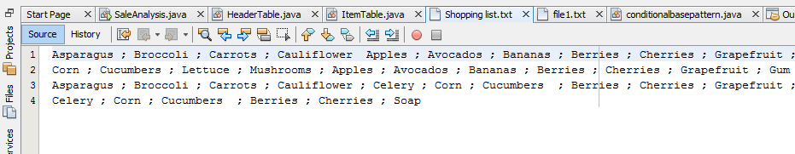
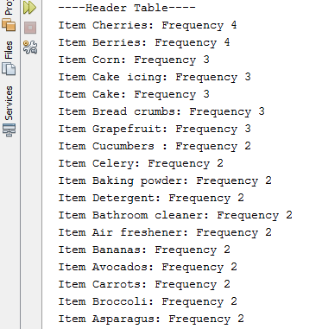
Header Table:

Output : Frequent Item Sets for an item
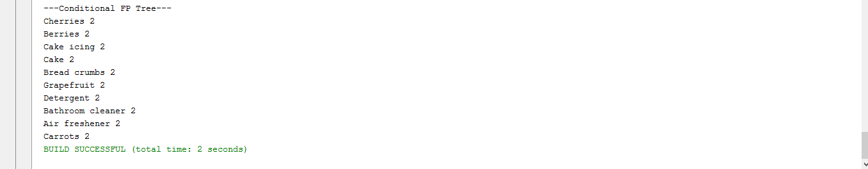

Conclusion:

A very efficient way of finding frequently occuring sets was learnt .
The other way would have been coming up with all the possible sets of items and finding their occurences and finding the highest occuring set out of them which is a inefficient brute force method (subset construction) .
An FP tree was used to come up with the same .

Frequent items bought by customers using FP trees was found which can now be used to make better marketing strategy by grouping these items together at a grocery store so that profits and sale of all these items can increased .

The following tasks were successfully given as output by the program :
(For a given minimum support threshold )
Frequency for each item was calculated and header table was created for it .
An FP tree was constructed and frequent item groups was mined from the tree .

